VERZEO MINOR PROJECT

• Project Name:

Azure Cloud Computing June Minor Project

• Project Description:

TASK 1:

Create a windows virtual machine using Azure and login using the RDP protocol.

**Create a new Windows virtual machine**

You can create Windows VMs with the Azure portal, Azure CLI, or Azure PowerShell. The best approach is to use the portal because the **Create a virtual machine** wizard collects all the required information and provides hints and validation messages throughout the process.

1. Sign in to the [Azure portal](https://portal.azure.com/learn.docs.microsoft.com) using the same account you used to activate the sandbox.
2. On the Azure portal, under **Azure services**, select **Create a resource**. The **Create a resource** pane appears.
3. In *Search services and marketplace* search box, search for and select *Windows Server*, and press Enter. Select **Windows Server** by Microsoft. The **Windows Server** pane appears.
4. There are several Windows Server options to choose from to create your VM. In the **Plan** dropdown list, scroll down, and select **[smalldisk] Windows Server 2019 Datacenter**.
5. Select **Create**. The **Create a virtual machine** pane appears.

**Configure the VM settings**

Azure presents a *wizard* as a series of tabs to walk you through all the configuration details for creating the VM. The first tab is **Basics**. You can select **Next** or **Previous** to move from one tab to another, or you can select any tab in the horizontal menu to move to a customizable configuration section.

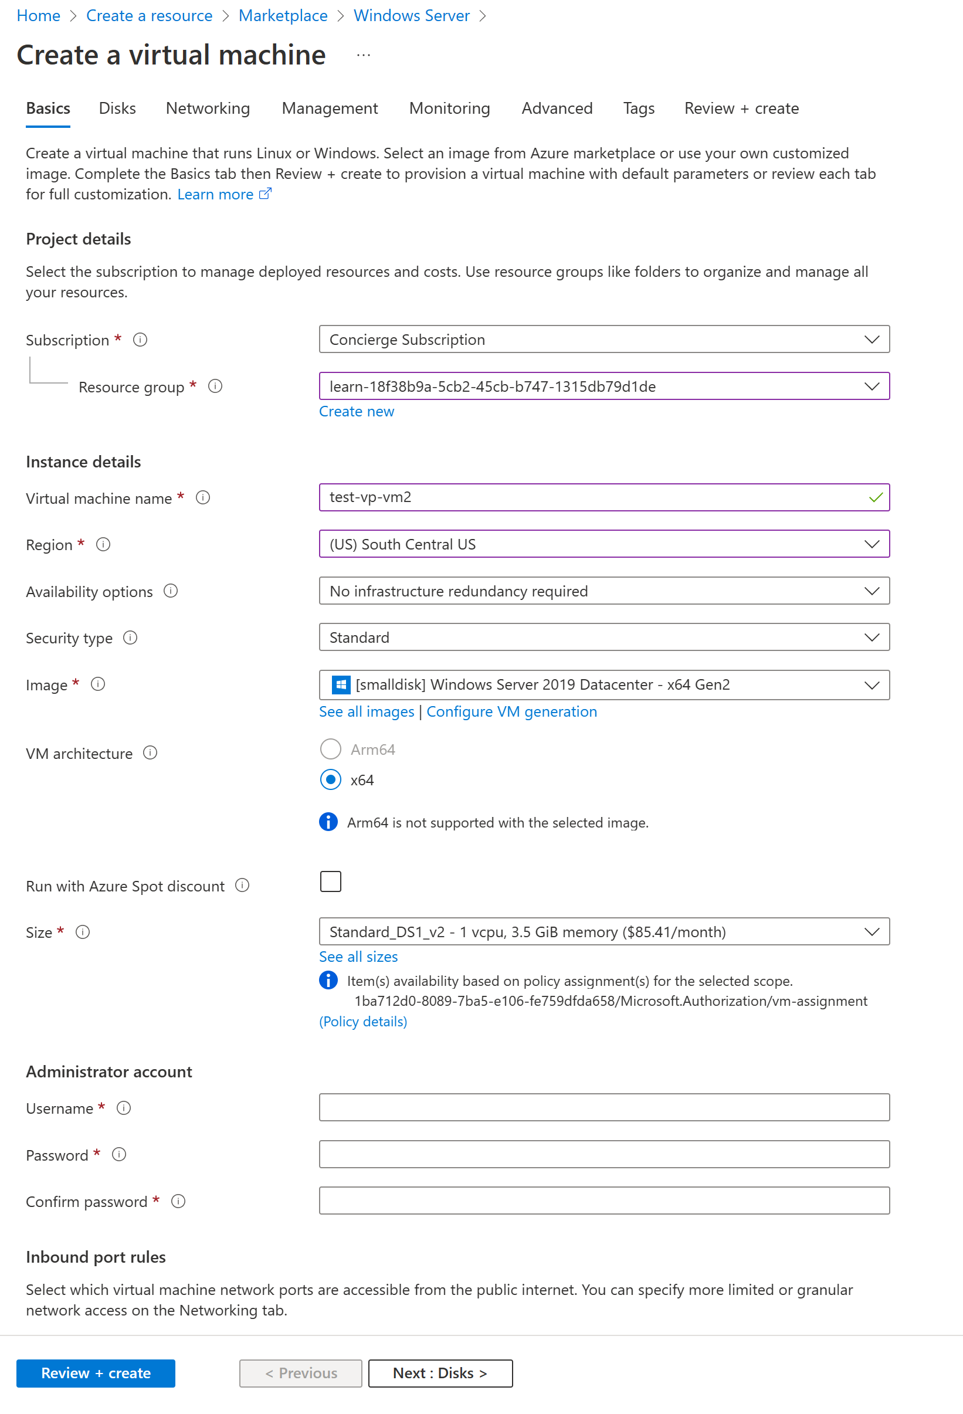

### Configure basic VM settings

**Note**

As you add or change settings in the wizard, Azure validates each value and places a green check mark next to a validated field, or red error indicator below the field. You can hover over an error indicator to get more information about a validation issue.

**Note**

It's a best practice to use a standard naming convention for resource names so you can easily identify their purpose. Windows VM names are a bit limited; they must be between 1 and 15 characters, cannot contain non-ASCII or special characters, and must be unique in the current resource group.

On the **Basics** tab, enter the following values for each setting.

Setting Value

Project details

Subscription Concierge Subscription (the subscription that

should be billed for VM hours).

Resource Group Select [sandbox resource group name].

Instance details

Virtual machine name Enter a name for your VM, such as test-vp-vm2

(for Test Video Processor VM #2).

Region Select a region close to you from the global

regions listed in the following table.

Availability options Accept default No infrastructure redundancy

required. This option is used to ensure the VM is

highly available by grouping multiple VMs

together to deal with planned or unplanned

maintenance events or outages.

Security type Standard

Image Select [smalldisk] Windows Server 2019

Datacenter - x64 Gen2 from the dropdown list.

VM architecture Accept default (x64)

Run with Azure Spot discount Accept default (unchecked).

Size The Size field isn't directly editable. Select or

accept the default Standard DS1 v2, which will

give the VM 1 CPU and 3.5 GB of memory.

Optionally, select the field to view recommended

or recently chosen sizes; select See all sizes to

explore filters for sizes based on vCPUs, RAM,

Data disks, operations per second, and cost. Select

the X in the top right of the pane to close the

pane.

Administrator account

Username Enter a username you'll use to sign in to the VM.

Password Enter a password that's at least 12 characters

long and has at least three of the following four

characteristics: one lower case character, one

uppercase character, one number, and one

special character that isn't '\' or '-'. Use

something you'll remember or write it down, as

you'll need it later.

Confirm password Confirm your password.

Inbound port rules

Public inbound ports Select Allow selected ports. We want to be able

to access the desktop for this Windows VM

using RDP.

Select inbound ports Select RDP (3389) from the dropdown list. As

the note in the UI indicates, we can also adjust

the network ports after we create the VM.

Licensing

Would you like to use an Leave unchecked

existing Windows Server License

The free sandbox allows you to create resources in a subset of the Azure global regions. Select a region from the following list when you create resources:

West US 2 West Europe Australia Southeast

South Central US Southeast Asia Central India

Central US Japan East

East US Brazil South

2.Select Next : Disks.

**Configure disks for the VM**

1. On the **Disks** tab, enter or select the following values for each setting.

Setting Value

Disk options

Encryption at host Accept the default (unchecked)

OS disk type Accept the default Premium SSD (locally

redundant storage).

Delete with VM Accept the default (checked)

Key management Accept the default.

Enable Ultra Disk compatibility Accept the default (unchecked)

Data disks

Select Create and attach

a new disk link. The Accept all the default values for the following

Create a new disk pane appears. settings: Name; Source type; Size; Key

management; and Enable shared disk. This is

where you could use a snapshot, or Storage

Blob, to create a VHD.

2.Select OK to save the settings, and close the pane.

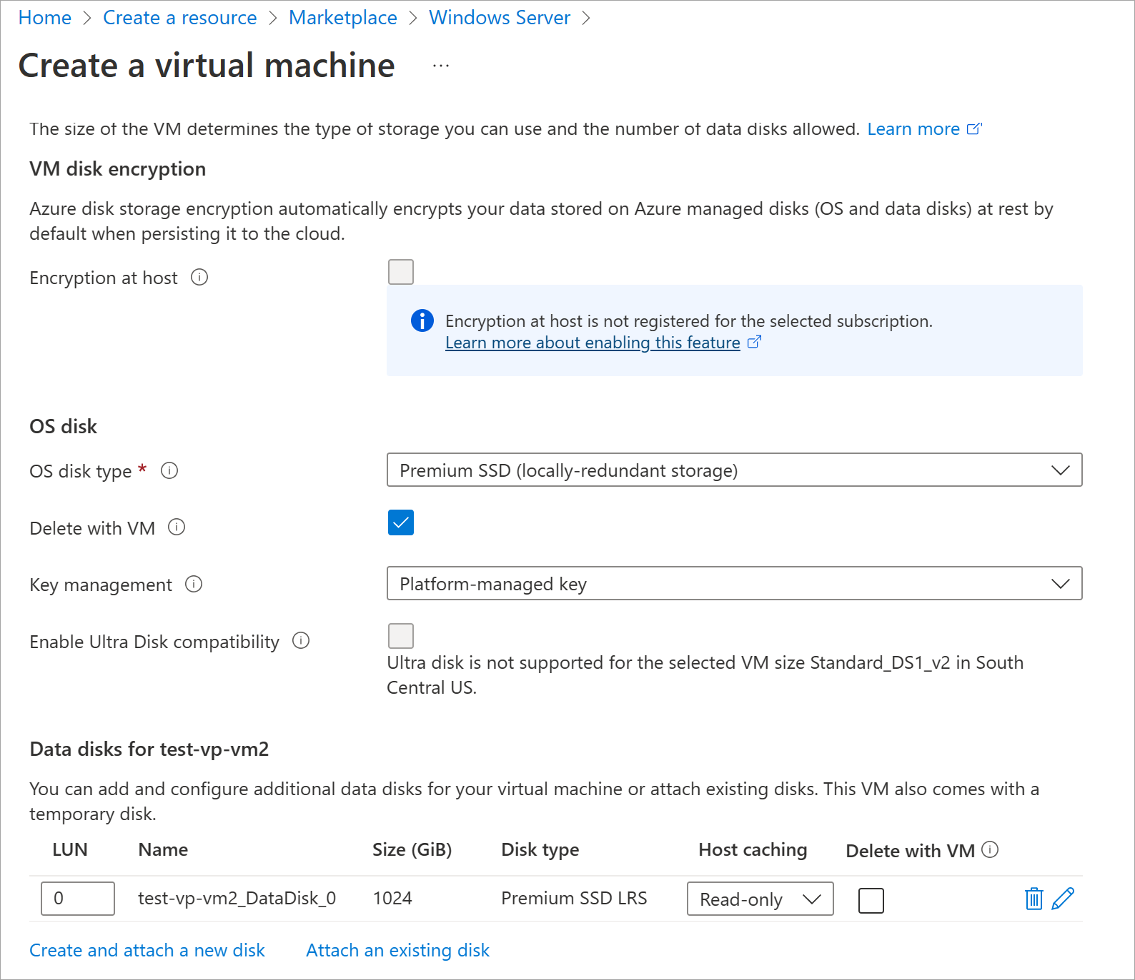

3.On the **Create a virtual machine** pane **Disks** tab, under **Data disks**, there should now be a new row showing the newly configured disk.

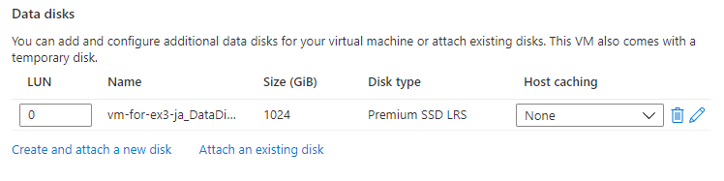

**Configure the network**

1. Select **Next : Networking**.

In a production system, where other components are already in use, it would be important to use an *existing* virtual network so that the VM can communicate with the other cloud services in the production solution. If no virtual network has defined in this location, create it here and configure the:

* + **Subnet**: First subnet to subdivide the address space; it must fit within the defined address space. After the VNet is created, you can add more subnets.
  + **Public IP**: Overall IPV4 space available to this network.

1. On the **Networking** tab, let's change some of the settings. Under the input field for **Virtual network**, select **Create new**. The **Create virtual network** pane appears.

3.On the **Create virtual network** pane, enter the following values for each setting.

Setting Value

Address space

Address range In the row below the heading, enter

172.16.0.0/16 to give the address space a

full range of addresses, then check the

box next to the address you just entered.

If another address range row exists, select

the Delete icon to delete it.

Subnets

Subnet name Select the checkbox in the row below the

heading, and enter default in the first

input field. If another row exists, select it

to delete it.

Address range In the empty input field, enter

172.16.1.0/24 to give the subnet 256 IP

addresses of space.

1. Select **OK** to save your settings and return to the **Create a virtual machine** pane.

## Finish configuring the VM and create the image

On the **Create a virtual machine** pane, the rest of the tabs have reasonable defaults and there's no need to change any of them. You can explore the other tabs if you like. Each field has an (i) icon next to it which, if selected, will show a detailed definition of that configuration setting. Reviewing field descriptions is a great way to learn about the settings you can use to configure the VM.

1. Select **Review + create**. The system will validate your options and display details about the VM being created.
2. Select **Create** to deploy the VM. The Azure dashboard will show the name VM that's being deployed and details about your deployment. Deployment may take several minutes.
3. After deployment completes, select **Go to resource**. Your virtual machine pane appears.